The test for the 3-cup anemometer behaviour involves an MFP107 Axial Fan Module by TecQuipment. The fan module has protective grilles at both ends of the duct, so the anemometer is set up just outside the duct to catch the exiting air whose flow is assumed to be uniform. The slide-valve is opened to 100% for maximum air flow. The fan speed is increased manually via the control panel by a step of 200 revolutions per minute; the volume metric flow rate is measured by the fan module and recorded via software once per second. For each fan speed value, the STM32F103C8T6 microcontroller counts the number of pulses from the anemometer for 20 seconds and displays on the Serial Monitor at the end of each sampling window. The mean volume metric flow rate of the fan module and the pulse count by the microcontroller are then recorded manually to a spreadsheet to be processed later.

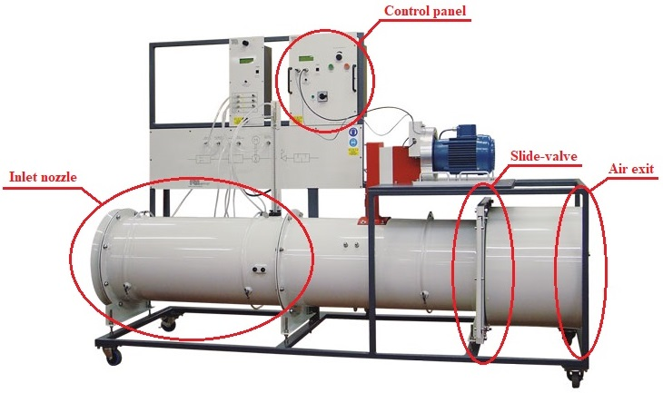

Figure 1. TecQuipment Axial Fan Module – MFP107 [1]

Although the MFP107 Axial Fan Module does not monitor the air speed through the duct directly, its built-in sensors still read the volume metric flow rate, which could still be used to calculate the air speed by dividing it by the cross-section of the duct, whose diameter is 40cm. The test run result is as follows.

|  |  |  |  |  |
| --- | --- | --- | --- | --- |
| **Duct diameter** | **D = 40 cm** |  | **R = 9.2 cm** | **T = 20 s** |
| **Mean flow rate** *fmean***, (m3/s)** | **Machine wind speed** *Vm***, (m/s)** | **Pulse count *n*** | **Read wind speed** *Vs***, (m/s)** | **Factor =** *Vm***/***Vs* |
| 0.85 | 6.764085081 | 30 | 0.433539786 | 15.60199386 |
| 0.91 | 7.241549911 | 55 | 0.794822941 | 9.110896948 |
| 0.958 | 7.623521774 | 92 | 1.329522011 | 5.734032014 |
| 1.022 | 8.132817592 | 135 | 1.950929038 | 4.168689601 |
| 1.14 | 9.071831756 | 176 | 2.543433412 | 3.566765976 |
| 1.33 | 10.58380372 | 254 | 3.670636856 | 2.88336987 |
| 1.44 | 11.4591559 | 289 | 4.176433274 | 2.743766068 |
| 1.56 | 12.41408556 | 329 | 4.754486322 | 2.611025613 |
| 1.65 | 13.13028281 | 370 | 5.346990696 | 2.455639733 |
| 1.78 | 14.16478994 | 383 | 5.534857937 | 2.559196658 |
| 1.9 | 15.11971959 | 437 | 6.315229552 | 2.394167855 |
| 2.03 | 16.15422672 | 505 | 7.297919734 | 2.213538558 |
| 2.15 | 17.10915638 | 538 | 7.774813499 | 2.200587369 |

[1] AYVA Educational Solutions, “TecQuipment Axial Fan Module – MFP107.” https://www.ayva.ca/eng/product/axial-fan-module/.